**Exercise 1: Control Structures**

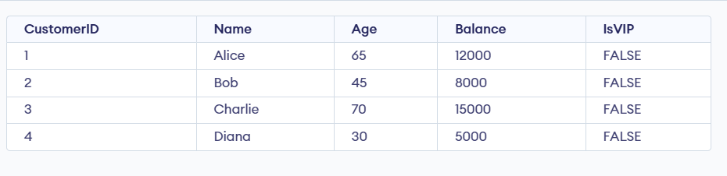

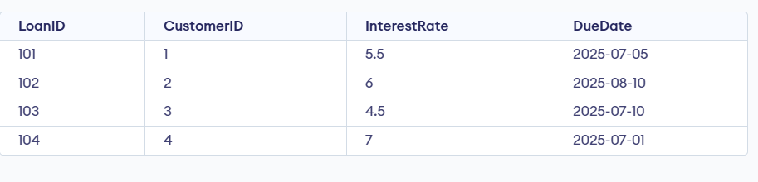

**Scenario 1:** The bank wants to apply a discount to loan interest rates for customers above 60 years old.

Question: Write a PL/SQL block that loops through all customers, checks their age, and if they are above 60, apply a 1% discount to their current loan interest rates.

BEGIN

FOR customer_rec IN (SELECT CustomerID, Age FROM CUSTOMERS) LOOP

IF customer_rec.Age > 60 THEN

UPDATE LOANS

SET InterestRate = InterestRate - 1

WHERE CustomerID = customer_rec.CustomerID;

END IF;

END LOOP;

COMMIT;

END;

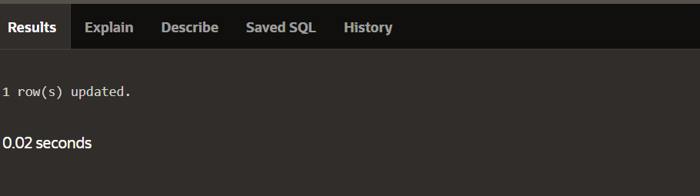

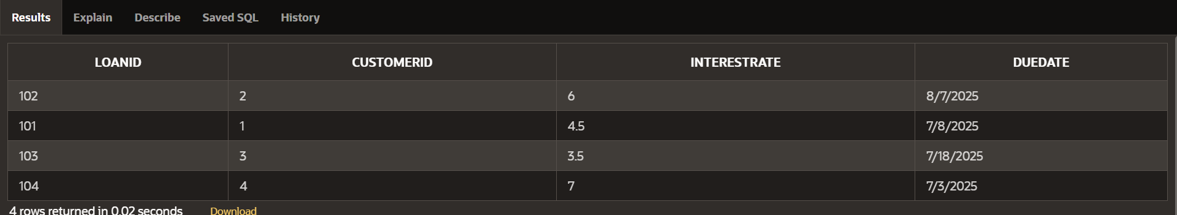

**Scenario 2:** A customer can be promoted to VIP status based on their balance.

**Question:** Write a PL/SQL block that iterates through all customers and sets a flag IsVIP to TRUE for those with a balance over $10,000.

BEGIN

FOR customer_rec IN (SELECT CustomerID, Balance FROM CUSTOMERS) LOOP

IF customer_rec.Balance > 10000 THEN

UPDATE CUSTOMERS

SET IsVIP = 'TRUE'

WHERE CustomerID = customer_rec.CustomerID;

END IF;

END LOOP;

COMMIT;

END;

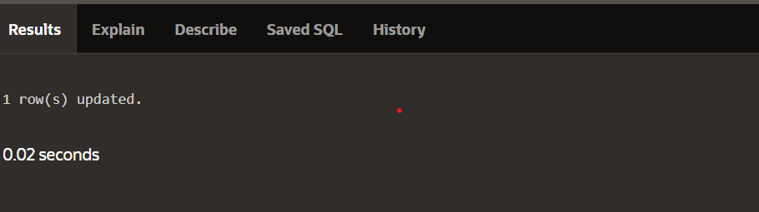

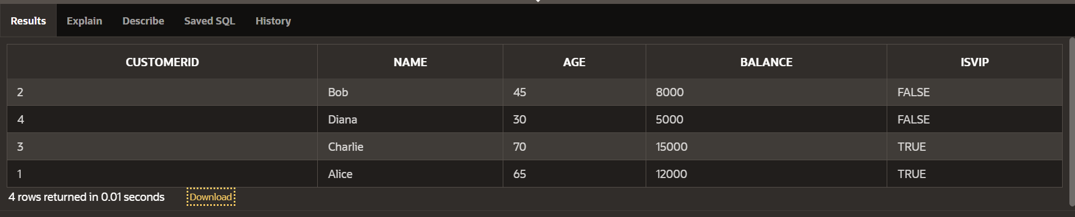

**Scenario 3:** The bank wants to send reminders to customers whose loans are due within the next 30 days.

**Question:** Write a PL/SQL block that fetches all loans due in the next 30 days and prints a reminder message for each customer.

DECLARE

v_due_date_limit DATE := SYSDATE + 30;

BEGIN

FOR loan_rec IN (

SELECT LoanID, CustomerID, DueDate

FROM LOANS

WHERE DueDate <= v_due_date_limit

) LOOP

DBMS_OUTPUT.PUT_LINE('Reminder: Loan ' || loan_rec.LoanID ||

' for Customer ' || loan_rec.CustomerID ||

' is due on ' || TO_CHAR(loan_rec.DueDate, 'DD-MON-YYYY'));

END LOOP;

END;

